Outreach Toolkit
For your convenience we have included resources on how you or your organization may want to share the Global Survey on Sustainability and the SDGs. Thank you for supporting this global movement!
Anonymous link to the survey: http://yale.qualtrics.com/jfe/form/SV_bHqkMiwa7zrLnrT
Global Survey website: www.globalsurvey-sdgs.com
Pictures and further material: www.globalsurvey-sdgs.com/spread-the-word/

QR Code
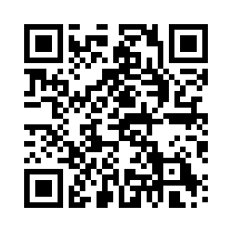

Email Template
The following email template can be used to reach organization members, colleagues, family and friends, etc. who may be interested in taking the Global Survey.
I am writing to request your participation in a short, yet very important survey called the Global Survey. The Global Survey is focused on establishing the status on the understanding of sustainability and knowledge of the Sustainable Development Goals amongst individuals and professionals; i.e. representatives of companies, politics, academia and civil society in all countries around the world. The aim is to prioritize relevant topics relating to the environment, social issues and the economy in the respective countries and to establish the urgency for action. Your participation in the survey will help stimulate and accelerate the process of change toward sustainable development worldwide!
The survey is brief and will only take 5-10 minutes to complete. To take the Global Survey and learn more about the project, please click the link below.
Thank you for your support and if possible, please share this email with others!
Link to Global Survey
For further information: www.globalsurvey-sdgs.com

Newsletter

What does sustainability mean to you? Take 5-10 min to share your thoughts! Click here: www.globalsurvey-sdgs.com

Option 1:
Sustainability is a topic of constant conversation these days. But the question remains – how do people from every part of the world perceive sustainability in their daily life and in the work place? And which of the 17 UN Sustainable Development Goals (SDGs) seem to be most important to people? For the first time ever, these questions are the focus of a survey called the “Global Survey” – where everyone can participate until the end of March 2018. The survey is available at www.globalsurvey-sdgs.com in 13 languages.
Option 2:
In 2015, the UN General Assembly adopted 17 Sustainable Development Goals (SDGs) as part of the 2030 Agenda for Sustainable Development. But how satisfied are people with the progress achieved? And what is important to them when it comes to sustainability in their daily life and in the work place? For the first time ever, these questions are the focus of a worldwide survey called the “Global Survey” – and everyone can participate until the end of March. The survey is available at www.globalsurvey-sdgs.com in 13 languages.
Option 3: (specific for companies/orgs):
What do you believe is the level of awareness of sustainability in your sector and organization/company? First the first time ever, these questions are the focus of a worldwide survey called the “Global Survey” – and everyone can participate until the end of March 2018. The survey is available at www.globalsurvey-sdgs.com in 13 languages.

Social Media Posts
Tell your followers about the Global Survey by using the hashtag #GlobalSurveySDG and/or tagging @GlobalSurveySDG on Twitter and Facebook or @globalsurvey17 on Instagram in your next post.
Wondering how to spark the interest of your followers? Check out the examples below!
Further social media posts can be found on our social media channels:
Twitter: @GlobalSurveySDG
Facebook: @GlobalSurveySDG
Instagram: globalsurvey17
LinkedIn: Global Survey on Sustainability and the SDGs

Pictures for social media posts can be found at:
www.globalsurvey-sdgs.com/spread-the-word/
Example 1 (B2C audience)
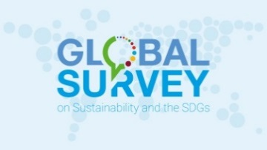  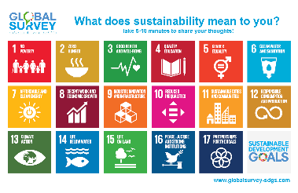  Example 2 (B2B or B2C) | How do you perceive sustainability where you work? How about in your daily life? For the first time ever, these questions are the focus of the #GlobalSurveySDG – where everyone can participate and share their thoughts! Check it out today: https://yale.qualtrics.com/jfe/form/SV_bHqkMiwa7zrLnrT.  Three years ago, the UN agreed on the Agenda 2030 for Sustainable Development. What has improved since then? What needs to be done? We at [Organization] support the #GlobalSurveySDG which gathers opinions on sustainability worldwide. Join the global movement by taking the survey today! https://yale.qualtrics.com/jfe/form/SV_bHqkMiwa7zrLnrT  We at [Organization] are an official supporter of the #GlobalSurveySDG which gathers opinions on sustainability and the #SDGs worldwide. Are you in? Take the survey and accelerate the process of change towards sustainable development in our society: https://yale.qualtrics.com/jfe/form/SV_bHqkMiwa7zrLnrT

Example 3 (B2C or personal post)
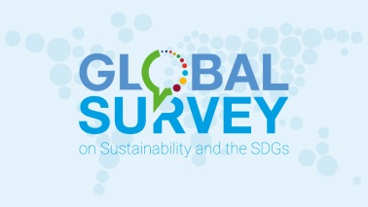 | Which Sustainable Development Goal #SDGs do you perceive as most important in your country? How about in your daily life and at work? Share your thoughts through the #GlobalSurveySDG today! https://yale.qualtrics.com/jfe/form/SV_bHqkMiwa7zrLnrT

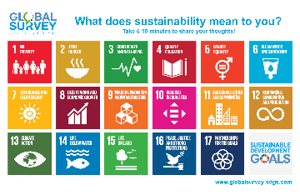
Great news, global #sustainability enthusiasts: The #GlobalSurveySDG is now available in 13 languages. Let's spread the message worldwide!
https://yale.qualtrics.com/jfe/form/SV_bHqkMiwa7zrLnrT
#arabic #chinese #english #french #german #indonesian #japanese #korean #portuguese #russian #spanish #thai #turkish
Did you know that there are over 2,880 minutes in a weekend? How about spending 5-10 of those doing something for a good cause? Take the #GlobalSurveySDG and promote sustainable development in your country! https://yale.qualtrics.com/jfe/form/SV_bHqkMiwa7zrLnrT

Further exemplary posts
- What does sustainability mean to you? Take part in the #GlobalSurveySDG and be part of the change!

- The #SDGs consists of 17 goals and 169 targets. They cover environmental, social and economic development issues. Take the #GlobalSurveySDG and bring the SDGs to life!

- What matters most to you? People, planet or prosperity? All three? Take the #GlobalSurveySDG and tell us what drives you in life!

- What do you expect from politicians in your country? To end war, make peace? Strengthen women’s rights? Protect marine life? Take the #GlobalSurveySDG and hold your leaders accountable!

- “We don’t have a plan B because there is no planet B.” Do you agree with Ban Ki-moon? Take the #GlobalSurveySDG and tell us what sustainability means to you!

- When do you take sustainability into consideration? When shopping? When voting? Other? Take the #GlobalSurveySDG and tell us!

- Do you feel that schools and other educational institutions sufficiently consider sustainability in education in your country? Take the #GlobalSurveySDG and put sustainability in the curriculum!

- SDG 8: 193 million people were unemployed in 2017. What is your company doing to address poverty and sustainable development? Take the #GlobalSurveySDG and promote sustainable development in your industry.

- SDG 17: Only together we can achieve sustainable development! Who are the most relevant partners for your organization to address sustainability challenges and the SDGs? Is it the private sector, academia, politics, civil society or media? Take the #GlobalSurveySDG and let us know!

Videos
- LEAVE NO ONE BEHIND - Shows the Sustainable Development Goals’ commitment to leave no one behind: English, French, Portuguese, Spanish, German

- NUMBERS IN ACTION -‘Numbers in Action’ explains the progress made under MDGs and targets for SDGs, bringing ‘Icons to Outcomes’ to life: English, French, Arabic, Spanish, German, Russian, Chinese

- PLAN - short clips from classic films send the message to the world that ‘We have a plan’: English, Arabic, French, Spanish, Russian German
- Check out the World's Largest Lesson for classroom videos, lessons & resources about the SDGs in multiple languages

Additional Resources
- Pictures: www.globalsurvey-sdgs.com/spread-the-word/
- SDG icons for download: https://www.un.org/sustainabledevelopment/news/communications-material/
- UNDP resources: www.undp.org/content/undp/en/home/sustainable-development-goals
- See actions from the Global Day to #act4SDGs in 2017 for inspiration

